**Development Management (Planning) Opportunities**

**Candidate Information Pack**

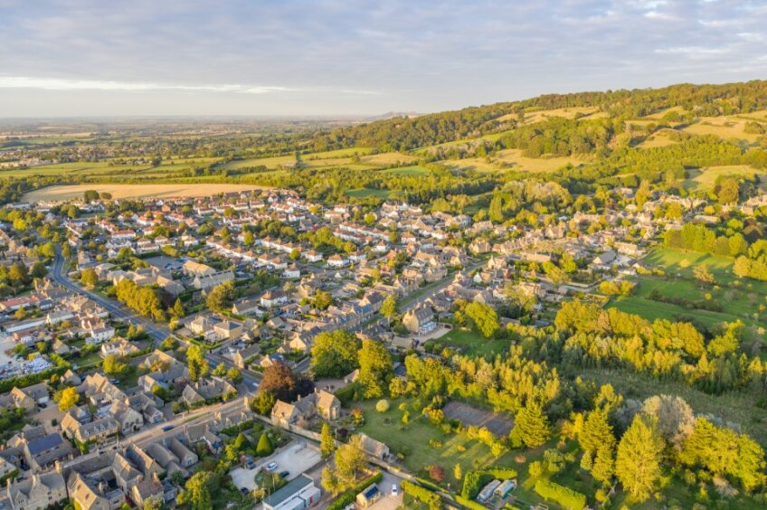

**Working for Wychavon and Malvern Hills**

Wychavon and Malvern Hills District Councils are rewarding places to work, with high levels of resident satisfaction and motivated staff who enjoy working for us. Located in south Worcestershire, both districts boast beautiful natural environments, a vibrant network of towns and villages, a rich heritage and plenty to see and do.

We pride ourselves on being progressive organisations spending time, energy and investment on what we know matters to our residents and communities – things like supporting our town centres and rural communities, creating jobs, keeping the streets clean, reducing our carbon footprint, helping people feel safe and preventing homelessness.,

We are two Councils with one vision, with planning and place-making at the heart of our two Corporate plans, and strong support for the planning function at the Senior Management level and with both sets of Executive Board members.

**Working with you**

Our staff are at the heart of what we do, and as a result we are always looking to recruit and develop the very best talent we can find.  That's why, as well as providing a satisfying job, we offer a range of attractive benefits, such as flexitime, generous holiday entitlements, a local government pension scheme, plenty of opportunities for personal development, and discounted gym membership.

As a shared service, the Planning function splits its time between Pershore and Malvern offices and we also offer the ability to work from home for up to 40% of the working week.

**Working in Planning and Infrastructure**

Covering an attractive and well connected part of the country with thriving villages, market towns and a host of heritage attractions, we are also a major growth area. Being strategically placed at the crossroads of the west Midlands, Herefordshire and Gloucestershire, there is substantial demand for growth, both for housing and employment land. The Planning directorate works positively with developers, landowners and site promoters as well as our internal housing and economic development teams, amongst others, to ensure the right growth takes place in the right locations.

With over 28,000 homes on track to be delivered by 2030, the South Worcestershire Development Plan Review, which is in preparation includes a government target for an extra 11,000 new homes, as well as policies that will support business growth, rural communities, and the fight against climate change. As part of the emerging rail-based strategies, we are working to plan for and deliver four new strategic sites, including two new garden communities which we are committed to being carbon neutral settlements. This is alongside a series of existing strategic sites with upcoming reserved matters applications due to be received in the coming months, a variety of major applications alongside an assortment of issues to be balanced in relation to minor and householder applications. The breadth of casework is vast stretching from rural hinterland and agricultural applications, to major urban extensions.

There is never a dull moment in Malvern Hills and Wychavon Councils’ planning team and it is a great place to grow your CV and cement your planning experience.

One of the strengths of the shared service is the well-resourced nature of the teams, including in Development Management, Policy and across our Specialist services such as heritage and urban design. Another strength of that team is that there’s always someone to learn from, who’s dealt with similar planning issues before, and who can support your learning. Similarly, there is always someone who will benefit from your experience and will seek your support. External learning and support for CPD is high on our agenda, and we are very receptive to listening to the suggestions of new starters who may join with bright ideas about service improvements.

We have fantastic opportunities to join an energetic, well-resourced and ambitious shared service. You’ll put your professional skills to work on a broad and challenging canvas. We’re absolutely committed to high quality design, sustainability, and the protection of our natural and built environment, as well as delivering the homes and employment locations that are residents, current and future need.

As skilled officers with a full or developing planning repertoire, you’ll develop an understanding of how to work collaboratively with our two sets of elected members, internal colleagues and external partners to deliver a great planning service.

**Team structure**

As part the wider Planning and Infrastructure Directorate, which includes teams such as Planning Policy, Natural and Historic Environment, Planning Support, Corporate Data and Land Charges, South Worcestershire Building Control and Planning Enforcement. Following a successful restructure Development Management currently has exciting opportunities available for Planners at various levels to join them.

The Development Management team structure can be seen below:

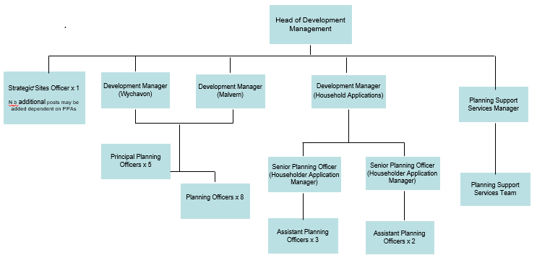

It’s an exciting time to be joining our service and we look forward to hearing from you!

For further information about Wychavon and Malvern Hills District Councilsplease visit [Jobs with Wychavon and Malvern Hills District Councils | WM Jobs](https://www.wmjobs.co.uk/employer/db38f6ee-c2c9-4cfc-a07b-603fc47efcc0/wychavon-and-malvern-hills-district-councils).

An introduction to our Planning and Infrastructure team:

<https://youtu.be/matT_0sa0Xw>

Why work for Wychavon and Malvern Hills District Councils?

<https://youtu.be/YSmILjLCIWI>